**An simple example that uses Jweed to download seismic data**

**Time range**: 2018-01-01 00:00:00 ----- 2018-02-01 00:00:00

**Magnitude**: mb 3.0-5.0

**Depth**: 0-30 km

**Event Region**: 120°E-140°E 0°N-10°N

**Station region**:120°E-150°E 0°N-20°N

**Components**: ?HZ

**Download software**: <http://ds.iris.edu/ds/nodes/dmc/software/downloads/jweed/>

1. This is the **user interface** that we can use to download seismic data from IRIS

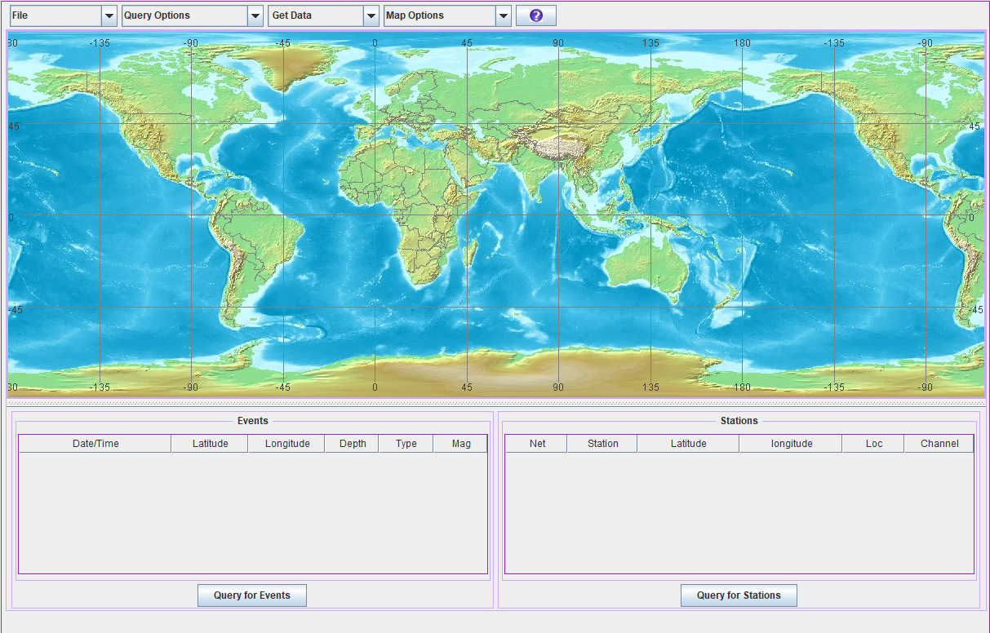

**Download eventlist**

1. **Query Options**>>>>>**Start/End Time**

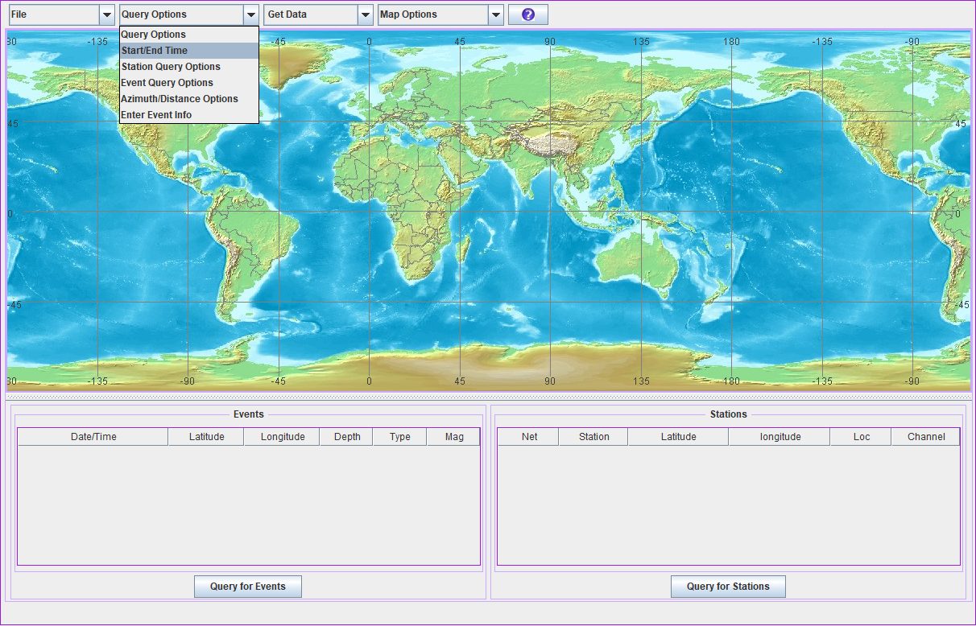

You can input the **start** and **end** time in the blanks. Here we want to download data of earthquakes occurred between **2018-01-01 00:00:00 ----- 2018-02-01 00:00:00**.

The label “**Start/End Time Option**” can be dragged anywhere. If it disappears, what you should do is click “**Start/End Time**” again. If you close this label, the time you set will not be lost. The other labels have the same property.

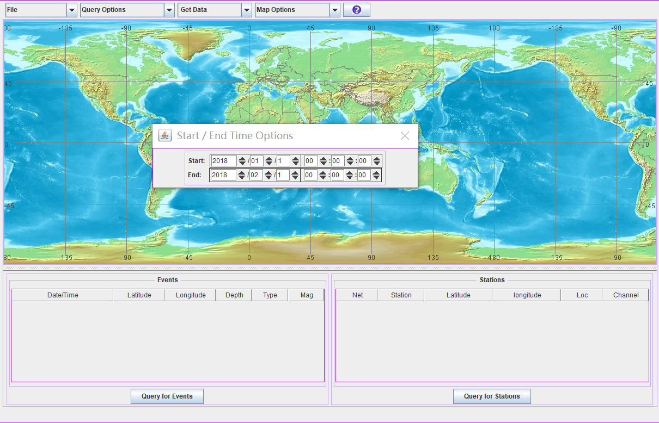

**3 Query Options**>>>>>**Event Query Options**

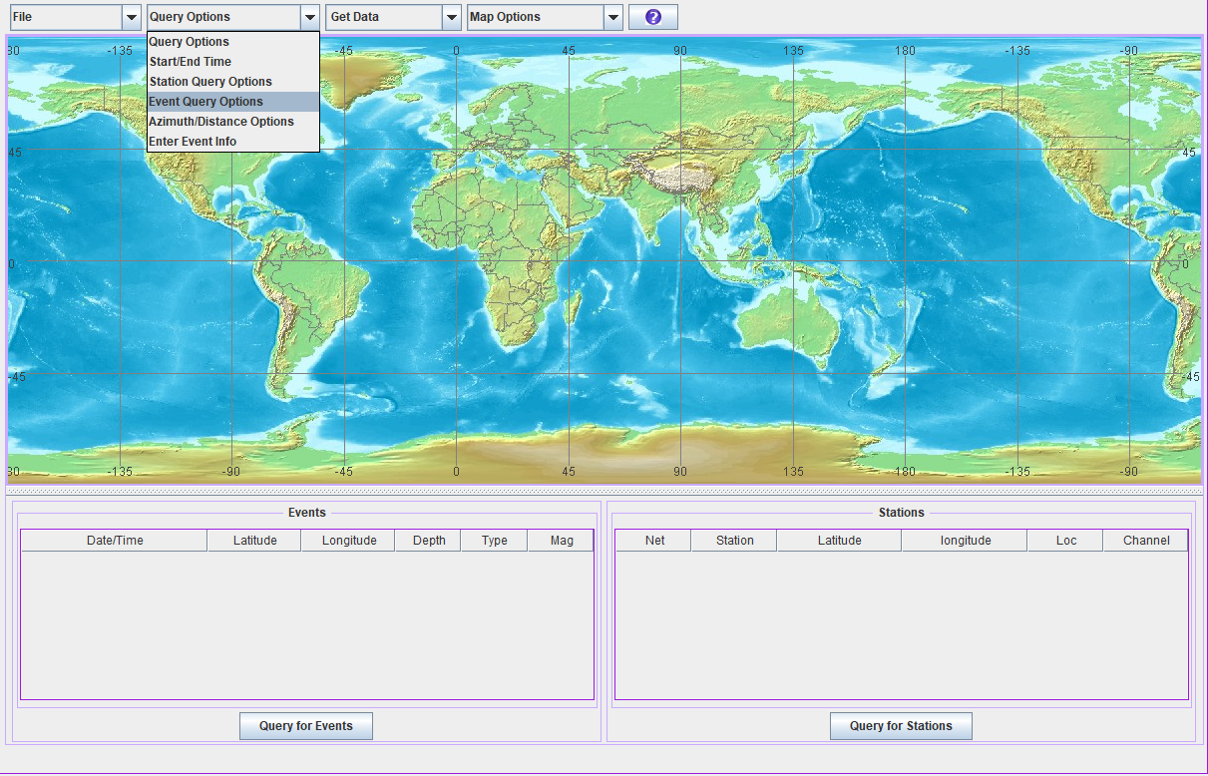

You can input the magtitudes in the blanks named **Mag** and input the depths of the events in the blanks named **Depth**. Here we want to download data of earthquakes with body-wave magnitudes between **3.0** and **5.0**. The magtitude **type** we choose here is **MB**. The event list we use is from **all** of the **Catalogs**.

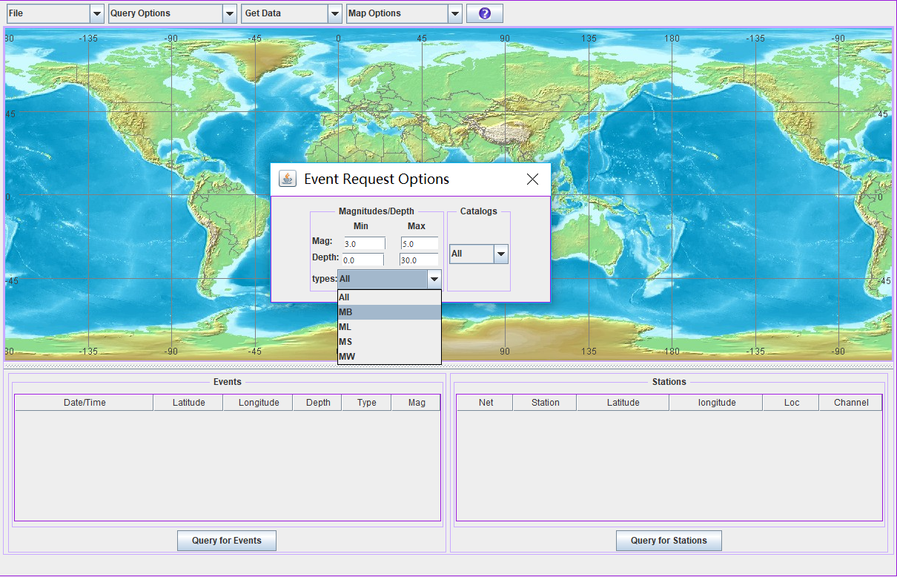

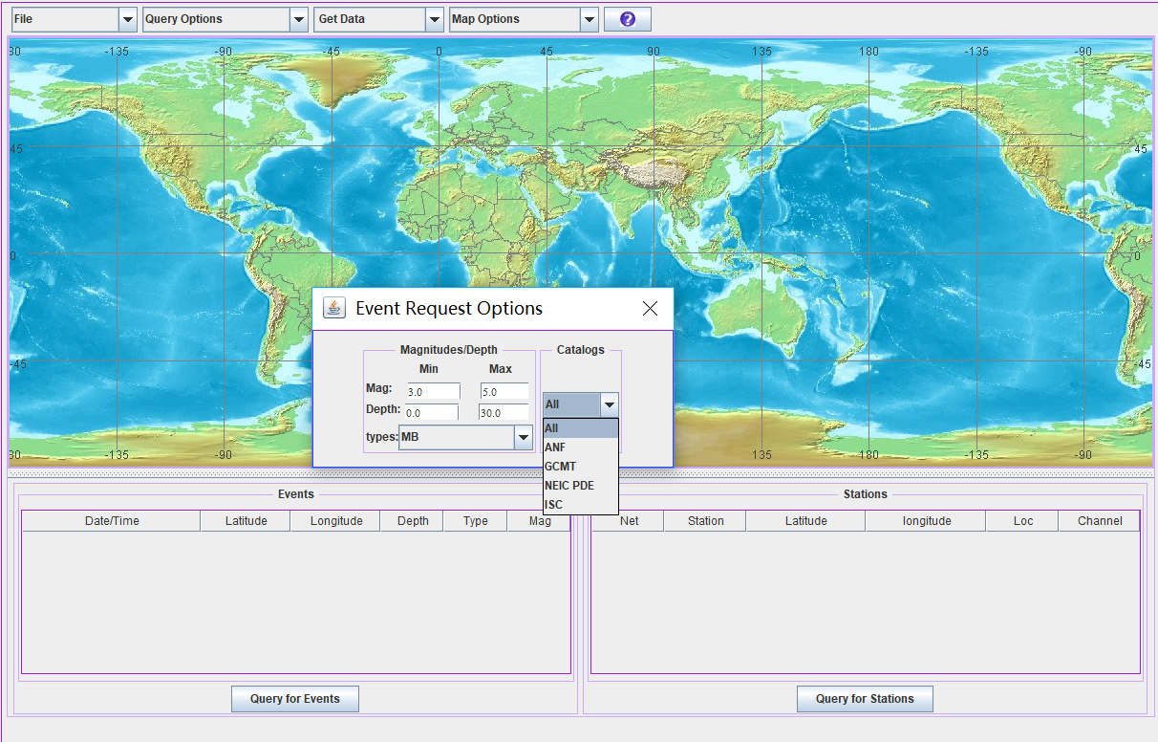

**4 Map Options**>>>>>**Enter Lat/lon, Points**

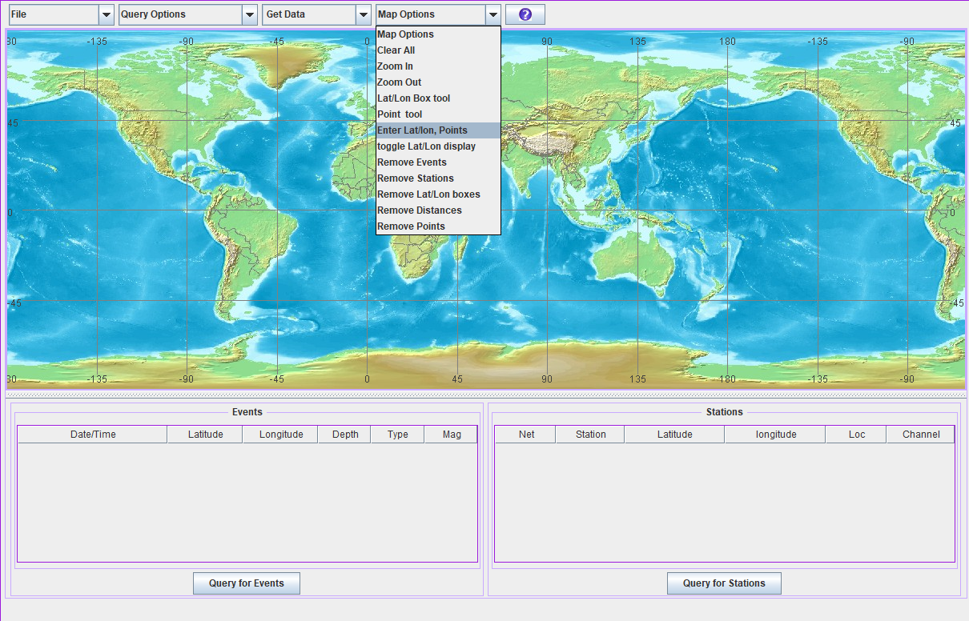

You can input the range of event locations in the blanks named **Lat** and **Lon**. The range we use here is **120°E-140°E, 0°N-10°N.** Finally, click **Map it** to ensure you have choose this region.

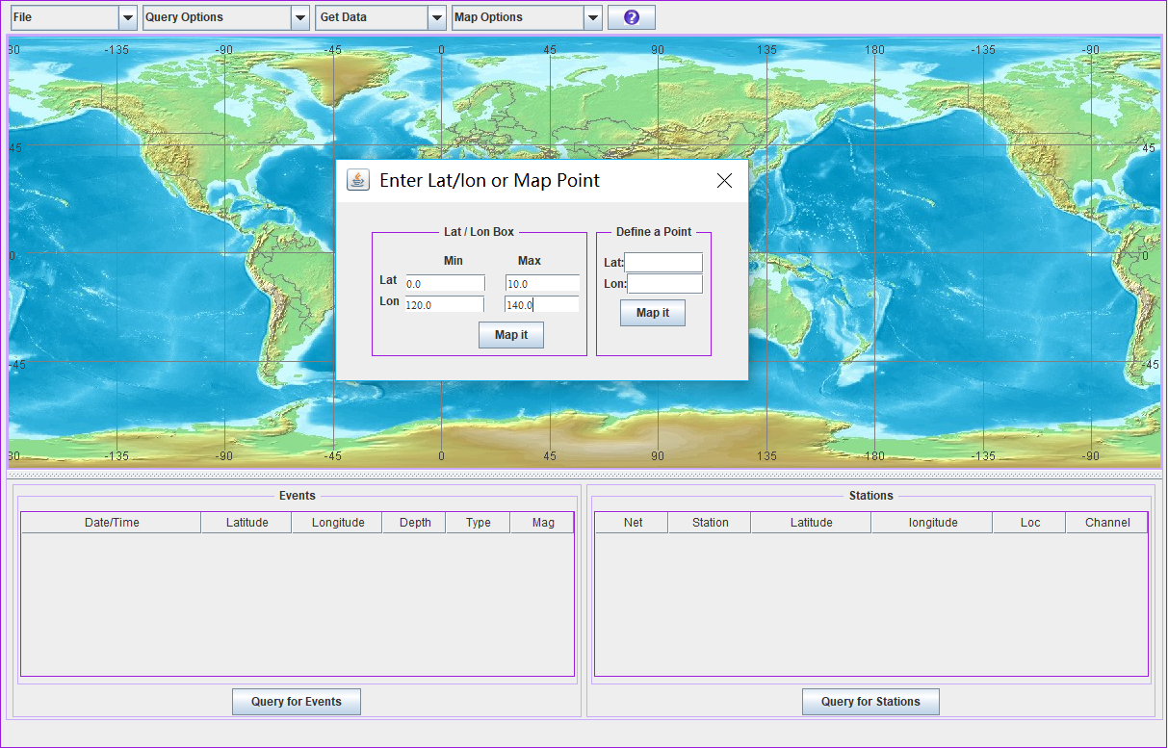

**5 Search the events and save the eventlist**

Click **Query for Events** to download eventlists

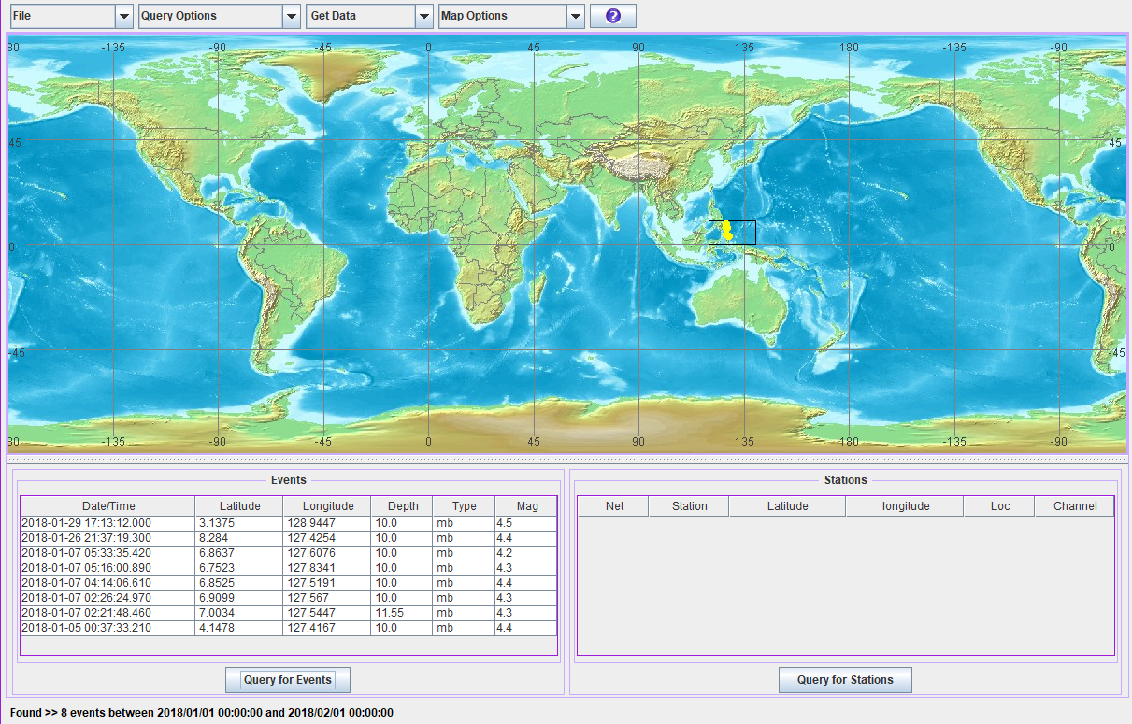

Click **File >>Save Event File** to save the eventlist

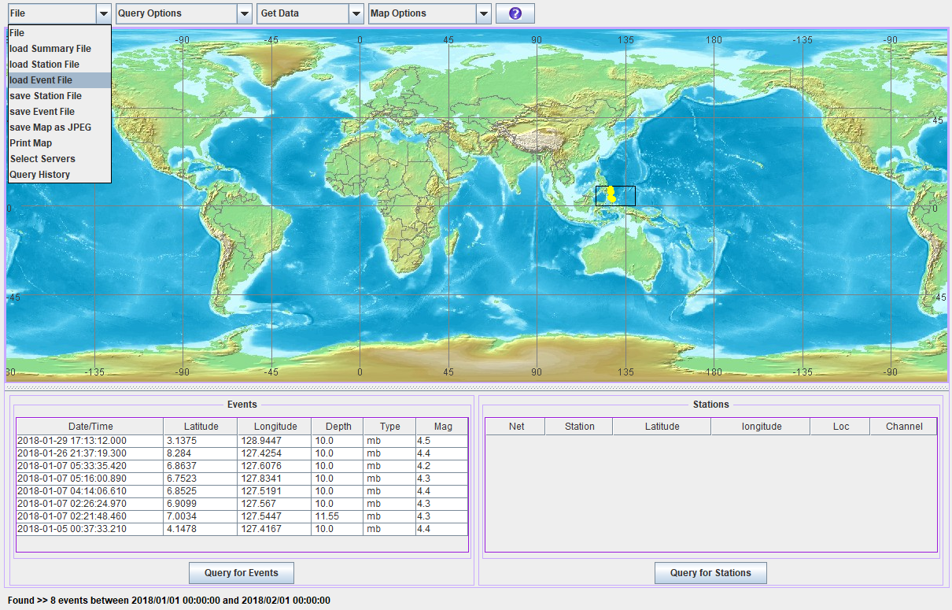

We will get a file including eventlist below. This list can be edited by adding or removing some events. Then click **Save Event File** to import the eventlist. The format of the list:

**xxxxx,year-month-day hour:minute:second,latitude,longitude,depth,xxxx,yyyyy,magnitude type,magnitude,**

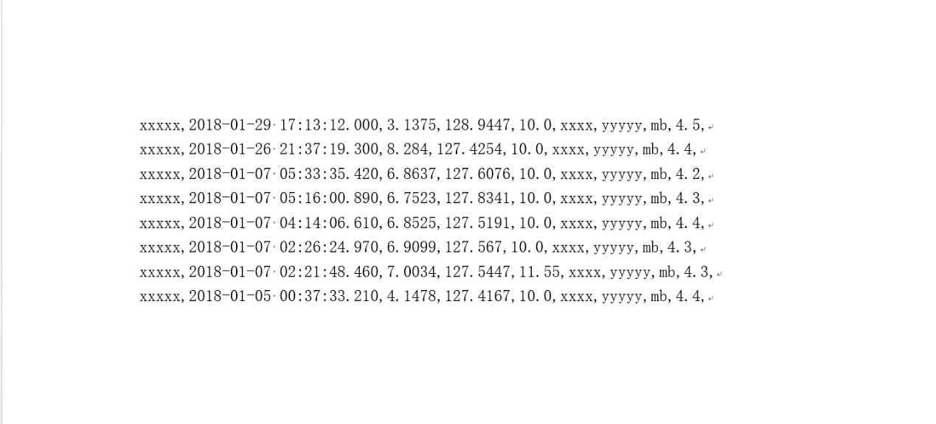

**Download Stations**

**6. Station Query Options**

**\***  for words with no less than 0 character

**？** for only one characters

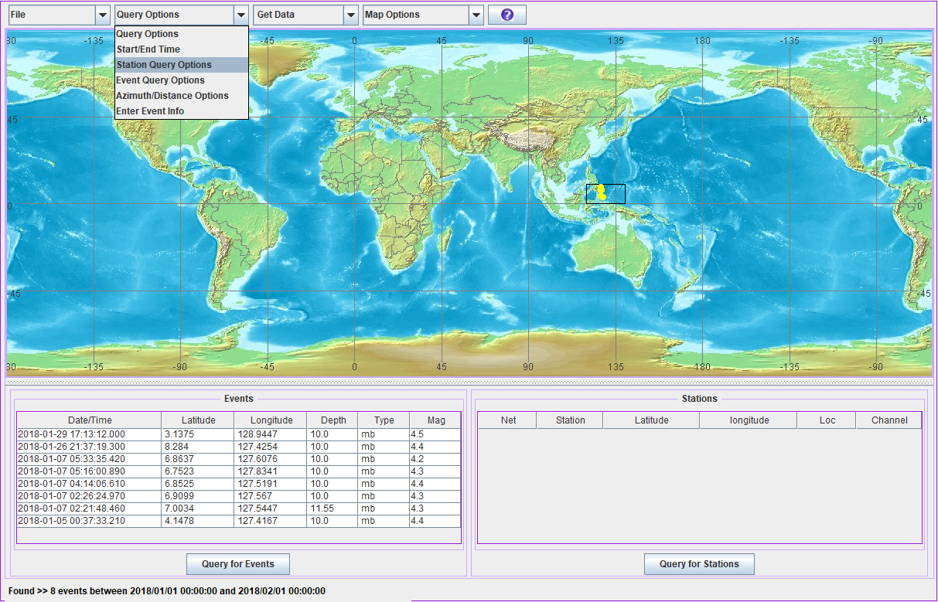

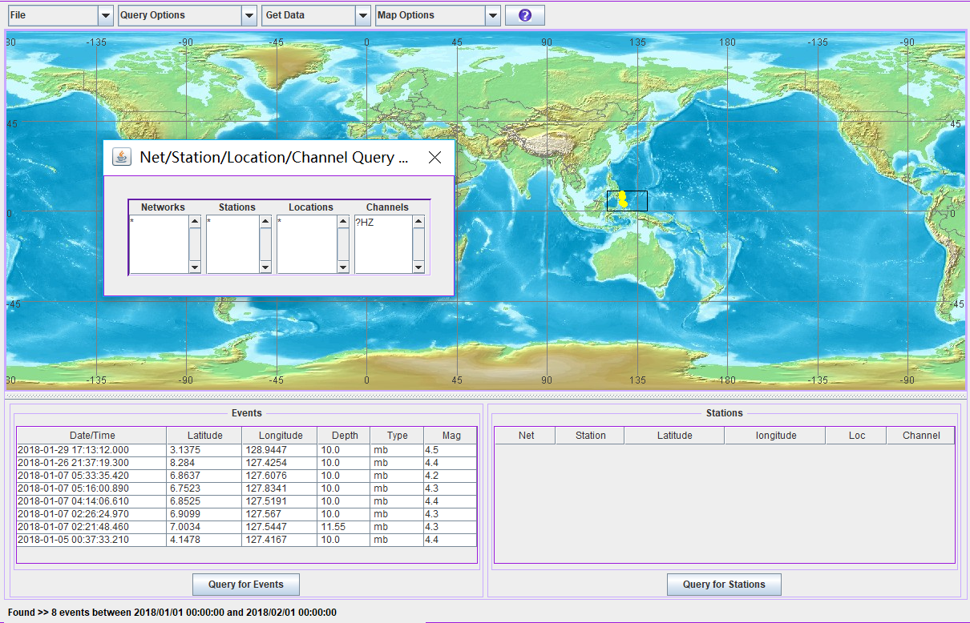

**7. Station Query Options**

Set the region where the stations locate, click **Map it** andthen **Query for stations**

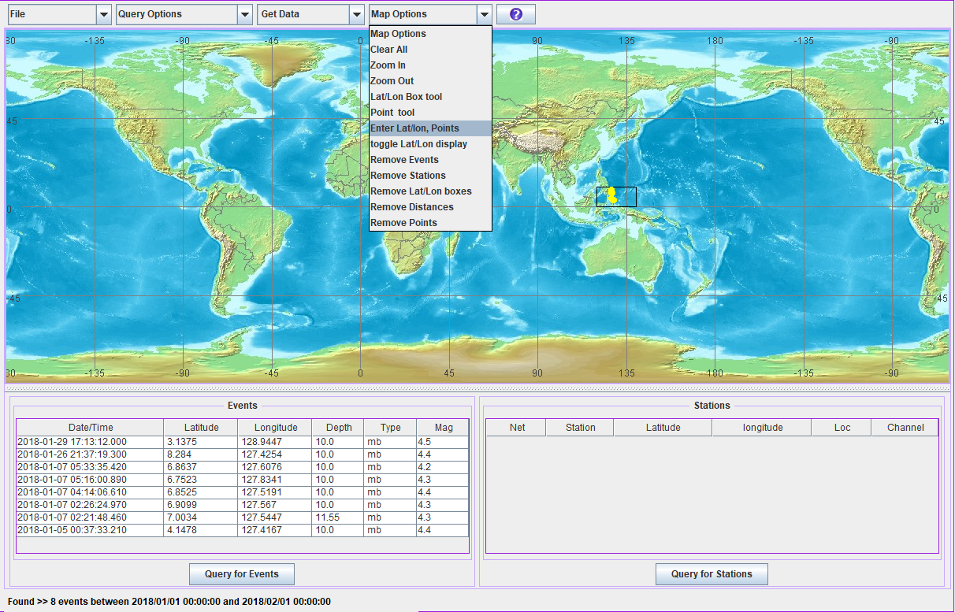

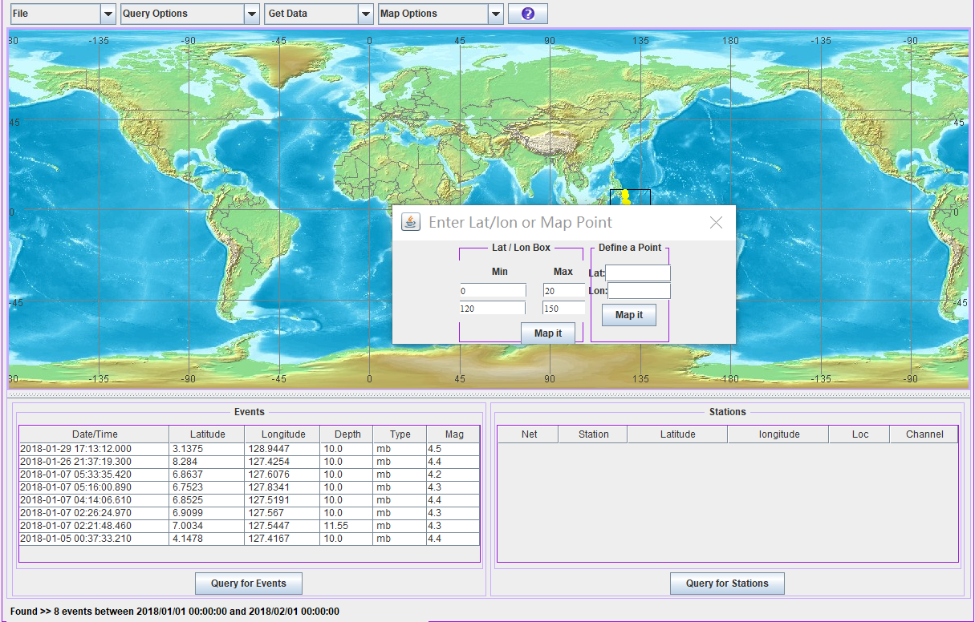

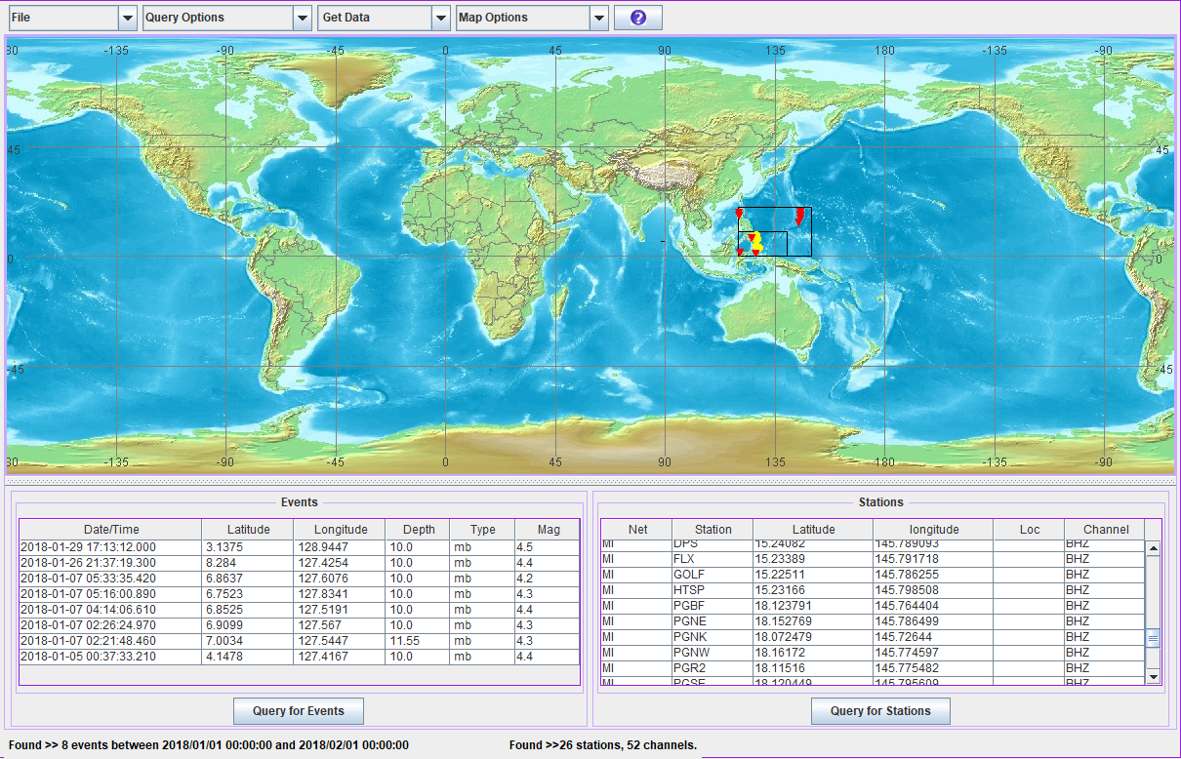

**Save Station File** and edit it by removing some unnecessary stations. When we are going to download the seismic data, we can **load Station File**

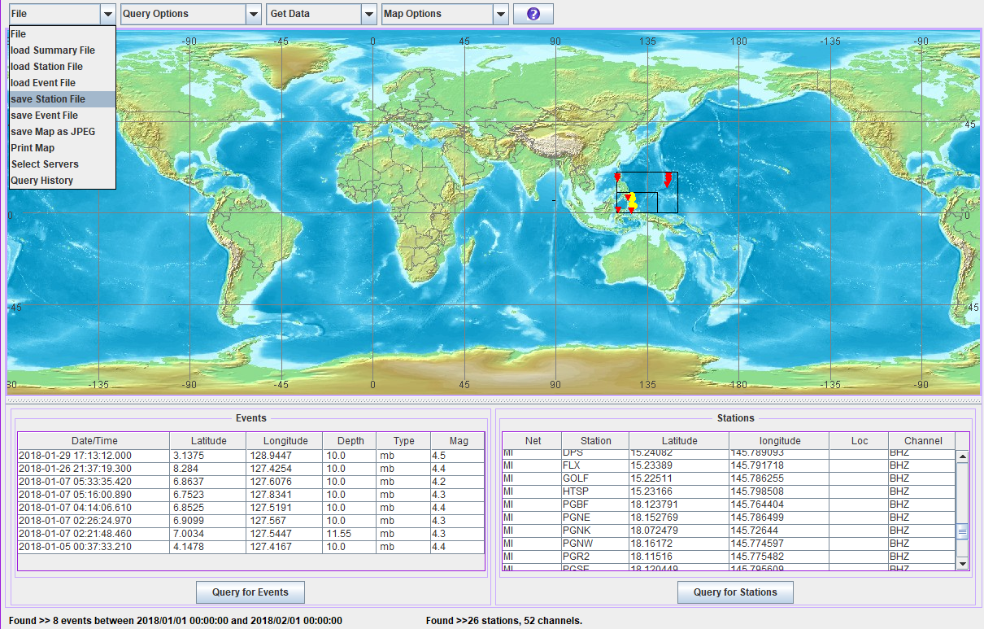

**8. Get Data**

Click **Breq_fast**

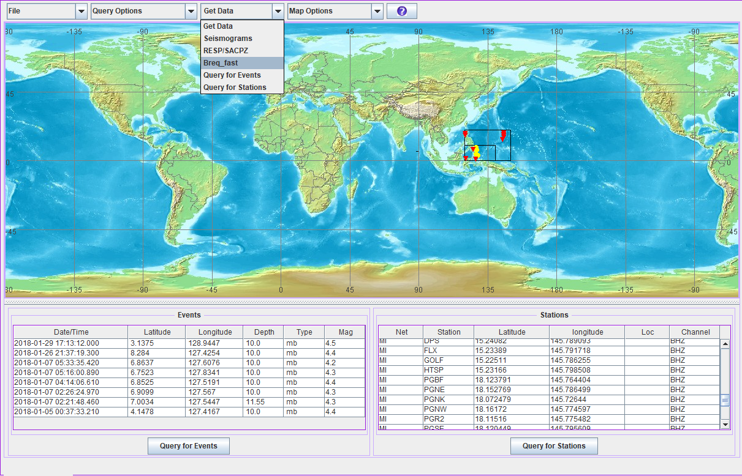

We name the **summary file** as **example**, we will finally get a file named **example.summary**. The waveform we cut here start at **300 s** before **P-wave onset** and end at **600 s** after **S-wave onset**，then click **OK**.

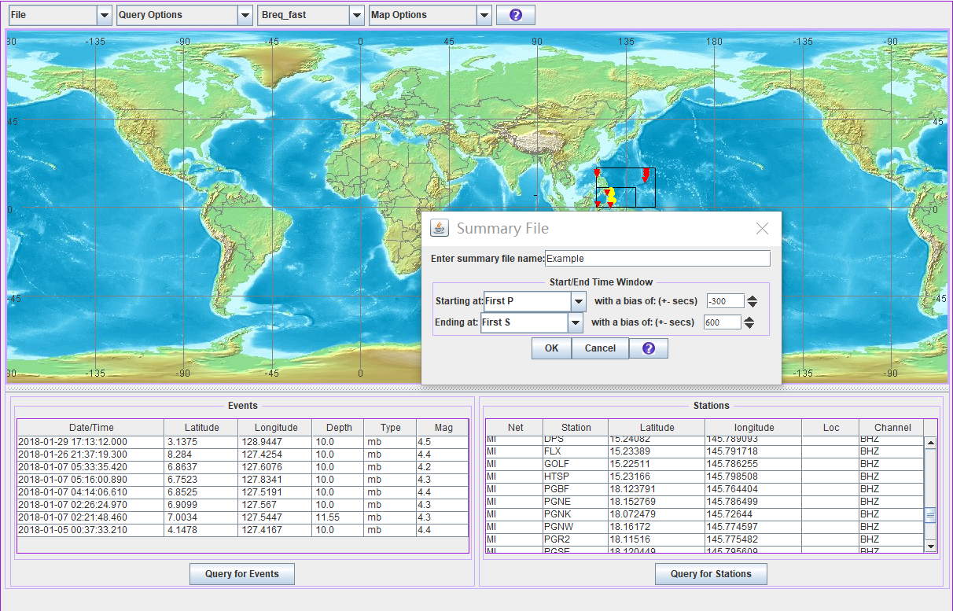

Input **Name(例如：小花花), Email(**very important**), Seed label(**name of the compressed seed file, which includes all of the data**).**

Click **Save Request Info,** then we can get the summary file named **example.summary.** We can use this summary file to arrange the SAC files according to the event.

Click **Send** [**bre_fast@iris.washington.edu**](mailto:bre_fast@iris.washington.edu)**.** When we see **Success…,** we can check our email and waiting for the data.

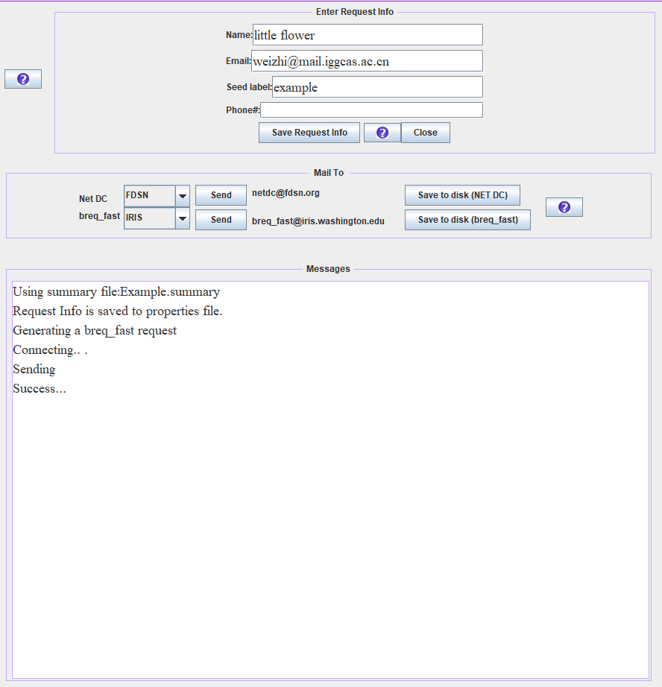

Firstly, we will get a email like the picture shown below



Then, we will get the second email, we can download the data from the email shown below



The content of this email. We can an attachment shown here.

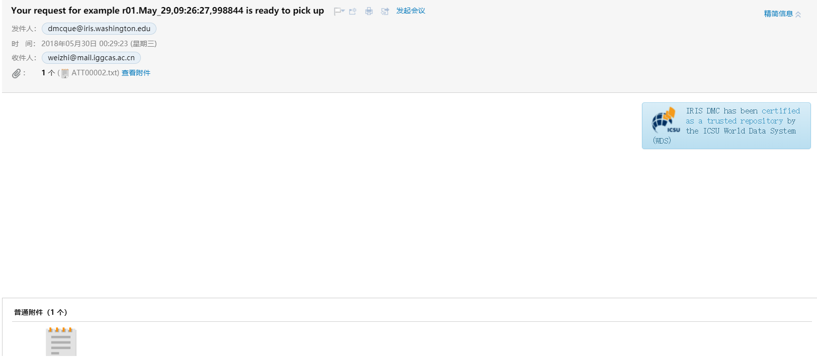

Here are some details in the attachment. Use any of the links, you will get what you want :)

Dear little_flower:

…………………………………………………………………………

TO DOWNLOAD your data, click on any one of the following URLs:

ftp://ftp.iris.washington.edu/pub/userdata/little_flower

http://ds.iris.edu/pub/userdata/little_flower

DIRECT LINK to the data files:

http://www.iris.edu/pub/userdata/little_flower/example.998844.seed

If upon clicking a file name in the list, your browser attempts to load the file to the

screen, hit STOP and BACK and try a different "click" method (i.e. some browsers use

shift-click, some use alt or option-click to download).

NOTE: MiniSEED requestors may download the dataless for the data header information

from any of the following:

http://www.iris.washington.edu/bud_stuff/bud/bud_start.pl?BUDDIR=/budnas/virtualnets/ALL

http://ftp.iris.washington.edu/pub/RESPONSES/DATALESS_SEEDS/

………………………………………………………………………………………………………….

You will get a seed file.You can use Rdseed to uncompress this file to get files in SAC format.